

Experiment No.: 04

Title: To use DML operations and SQL queries to
Populate the database

Batch: B1 Roll No.: 1914078 Experiment No: 04

Aim: To use DML operations and SQL queries to populate the database .

___________________________________________________________________________

Resources needed: PostgreSQL PgAdmin4

___________________________________________________________________________
Theory:

The Data Manipulation Language (DML) is used to populate the table with values, modify the table values and remove the rows of the table.

The DML statements are: SELECT

INSERT
UPDATE

DELETE

__________________________________________________________________________
Procedure:

CREATE TABLE products ( product_no integer,

name text, price numeric );

Let us consider the above products table

Inserting rows:
The INSERT command requires the table name and column values

INSERT INTO products VALUES (1, ’Cheese’, 9.99);

If we don’t have values for all the columns, you can omit some of them. In that case, the columns will be filled with their default values. For example:

INSERT INTO products (product_no, name) VALUES (1, ’Cheese’)

Updating the values:
The UPDATE command requires three pieces of information:

- The name of the table and column to update
- The new value of the column
- Which row(s) to update
UPDATE products SET price = 10 WHERE price = 5;
UPDATE products SET price = price * 1.10;

Deleting rows:

The syntax of the DELETE command is similar to the UPDATE command. DELETE FROM products WHERE price = 10;

Retrieving values:

The general syntax of the SELECT command is SELECT select_list FROM table_expression SELECT * FROM table1;
SELECT * FROM products WHERE price=10;
SELECT product_no, name FROM products WHERE price=10;

Example:

insert into department values('IT', 101, 'mumbai');
insert into department values('COMP', 102, 'mumbai');
insert into department values('ETRX', 103, 'delhi');
insert into department values('EXTC', 104, 'chennai');
insert into department values('account', 105, 'mumbai');

insert into employee values('anita','m','sharma','emp0001',20000,'mumbai',101);
insert into employee values('nita','g','patil','emp0004',10000,'mumbai',101);
insert into employee values('krupita','v','jetali','emp0003',20000,'delhi',103);
insert into employee values('juhi','r','verma','emp0002',15000,'delhi',104);
insert into employee values('anita','m','sharma', 'emp0005',20000,'mumbai',104);

insert into project values( 1, 'mumbai','website',101);
insert into project values( 2, 'chennai','coding',101);
insert into project values( 3, 'mumbai','testing',102);
insert into project values( 4, 'delhi','documentaion',103);

insert into works_on values(1,'emp0001', 12);
insert into works_on values(1,'emp0002', 10);
insert into works_on values(2,'emp0001', 6);
insert into works_on values(3,'emp0004', 2);

insert into dependent values(‘emp0001’, ‘sunita’,’sister’);
insert into dependent values(‘emp0001’, ‘nita’,’mother’);
insert into dependent values(‘emp0002’, ‘kamal’,’brother’);
insert into dependent values(‘emp0004’, ‘krishna’,’father’);

select * from employee;
select * from department;
select * from project;
select * from dependent;
select * from works_on;

1) employee

fnamemnamelnamessn salary ecitydno
---------------------------------------- ------------------------------ ----------------------------------
anita m sharma emp0001 20000 mumbai101
juhi r verma emp0002 15000 delhi 104
krupita v jetali emp0003 20000 delhi 103
nita g patil emp0004 10000 mumbai 101
anita m sharma emp0005 20000 mumbai104

2) department

dnamednodlocation
------------------------------ ----------- -----------------------------------
IT 101 mumbai
COMP 102 mumbai
ETRX 103 delhi
EXTC 104 chennai
account 105 mumbai

4) project
pnoplocationpnamedno
----------- ---------------------------------------- -------------------- -----------
1 mumbai website 101
2 chennai coding 101
3 mumbai testing 102
4 delhidocumentaion 103

5) dependents

ssndepname relation
-------------------- ------------------------------ ------------------------------
emp0001nita mother
emp0001sunita sister
emp0002kamal brother
emp0004krishna father

6) woks_on

pnossnno_of_hrs
----------- -------------------- -----------
1 emp0001 12
1 emp0002 10
2 emp0001 6
3 emp0004 2

__________________________________________________________________________

Results: (Queries printout with output as per the format)
- Write 10 queries using ‘from’ and ‘where’ clause.

- Insert Row:
CREATE TABLE employee (
ELoginID text PRIMARY KEY,
Name text UNIQUE,
Password text
);
INSERT into employee values('22', 'Devansh','abcdef');
INSERT into employee values('23', 'Devan','abcde');
INSERT into employee values('24', 'Deva','abcd');
INSERT into employee values('25', 'Dev','abc');
SELECT * from employee;
Output:
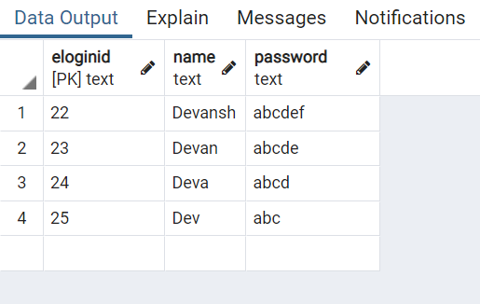

- Updating the values:

- Specific Value
CREATE TABLE employee (
ELoginID text PRIMARY KEY,
Name text UNIQUE,
Password text
);
INSERT into employee values('22', 'Devansh','abcdef');
INSERT into employee values('23', 'Devan','abcde');
INSERT into employee values('24', 'Deva','abcd');
INSERT into employee values('25', 'Dev','abc');
UPDATE employee SET Name = 'Devansh Shah' WHERE Name = 'Devansh';
SELECT * from employee;
Output:
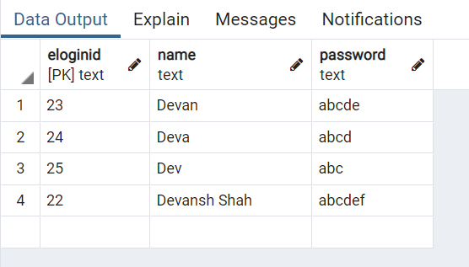

- Updating all values:
CREATE TABLE employee (
ELoginID text PRIMARY KEY,
Name text UNIQUE,
Password text
);
INSERT into employee values('22', 'Devansh','abcdef');
INSERT into employee values('23', 'Devan','abcde');
INSERT into employee values('24', 'Deva','abcd');
INSERT into employee values('25', 'Dev','abc');
UPDATE employee SET Password = 'xyz';
SELECT * from employee;

Output:
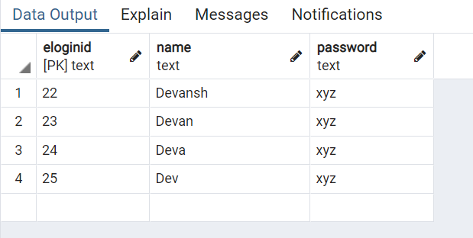

- Deleting rows:
CREATE TABLE employee (
ELoginID text PRIMARY KEY,
Name text UNIQUE,
Password text
);
INSERT into employee values('22', 'Devansh','abcdef');
INSERT into employee values('23', 'Devan','abcde');
INSERT into employee values('24', 'Deva','abcd');
INSERT into employee values('25', 'Dev','abc');
DELETE FROM employee WHERE ELoginID = '24';
SELECT * from employee;
Output:
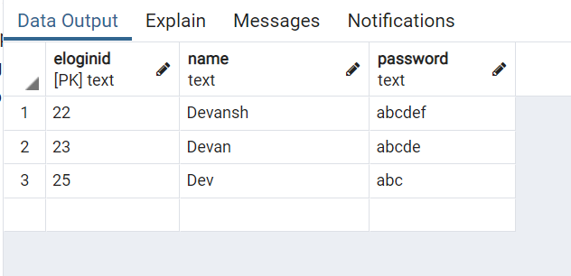

- Retrieving values from table:
CREATE TABLE employee (
ELoginID text PRIMARY KEY,
Name text UNIQUE,
Password text
);
INSERT into employee values('22', 'Devansh','abcdef');
INSERT into employee values('23', 'Devan','abcdef');
INSERT into employee values('24', 'Deva','abcd');
INSERT into employee values('25', 'Dev','abc');
SELECT * from employee;
Output:
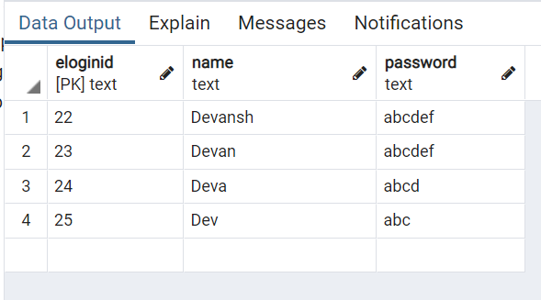

SELECT * FROM employee WHERE Password = 'abcdef';
Output:
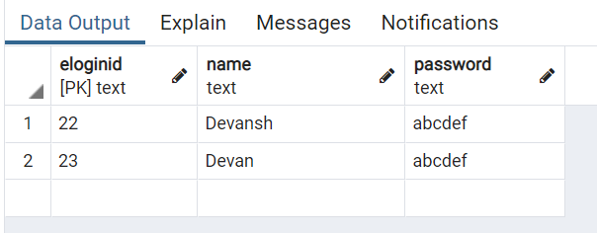

SELECT ELoginID FROM employee WHERE Password = 'abcdef';
Output:
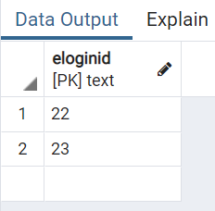

SELECT * FROM employee WHERE ELoginID > '22';
Output:
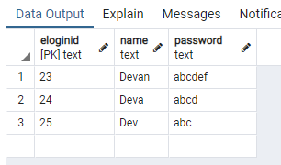

SELECT Name,Password FROM employee WHERE ELoginID > '22';
Output:
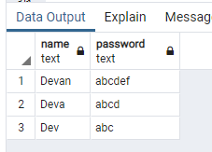

SELECT Name,Password FROM employee WHERE ELoginID >= '22';
Output:
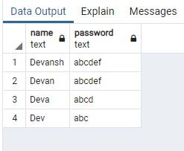

SELECT Name,Password FROM employee WHERE ELoginID < '24';
Output:
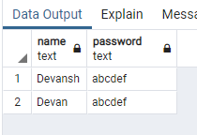

SELECT Name,Password FROM employee WHERE ELoginID != '24';
Output:
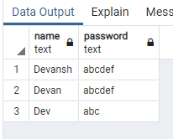

SELECT Name,Password FROM employee WHERE ELoginID BETWEEN '22' and '23';
Output:
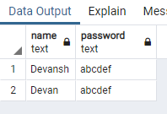

SELECT Name,Password FROM employee WHERE ELoginID = '22' OR ELoginID = '24';
Output:
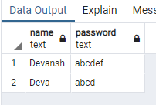

SELECT Name,Password FROM employee WHERE ELoginID IN ('22','23','24');
Output:
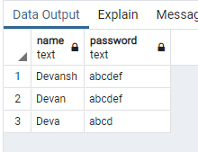

Example:

- To extract the name and ssn of all the employees:
Select fname, mname, lname, ssn from employee;

fnamemnamelnamessn
---------------------------------------- ---------------------------------------- -----------------------------
anitasharmam emp0001
juhiverma r emp0002
krupitajetali v emp0003
nitapatil g emp0004
anitasharma m emp0005

- To select names and city of the employees earning salary more then 10000:
Select fname, mname, lname, ecity from the employee where salary>10000;

fnamemnamelname ecity
---------------------------------------- ------------------------- ----------------------------------------
anitasharmam mumbai
juhivermar delhi
krupitajetaliv delhi
anitasharma m mumbai

- TO get the details of the cities of the employees in our company:
select distinct ecity from employee;
ecity
------------
delhi
mumbai

- To find the name of the department located in Mumbai and with department number 101:
select dname from department where dlocation=’Mumbai’ and dno=101;
dname
--------------

- To delete all dependent whose relation is mother with employee:
delete form dependent where relation=’mother’;
ssndepname relation
-------------------- ------------------------------ ------------------------------
emp0001sunita sister
emp0002kamal brother
emp0004krishna father

- Update relation employee to increment salary of all employees working in Department 101 by Rs. 10000:
update employee set salary=salary+10000 where dno=101;
fnamemnamelnamessn salary ecitydno
---------------------------------------- ------------------------------ ----------------------------------
anita m sharma emp0001 30000 mumbai101
juhi r verma emp0002 15000 delhi 104
krupita v jetali emp0003 20000 delhi 103
nita g patil emp0004 20000 mumbai 101
anita m sharma emp0005 20000 mumbai104

___________________________________________________________________________

Outcomes: Illustrate the concept of security, Query processing, indexing and Normalization for Relational database

__________________________________________________________________________________
Questions:

Q1 Explain various data types used in SQL

- Numeric types consist of two-byte, four-byte, and eight-byte integers, four-byte and eight-byte floating-point numbers, and selectable-precision decimals. Eg) smallint, integer, bigint, decimal, numeric, etc
- Date and Time data types such as Date, Time, Datetime etc.
- Character and String data types such as char, varchar, text etc.
- Unicode character string data types, for example nchar, nvarchar, ntext etc.
- Binary data types such as binary, varbinary etc.
- Miscellaneous data types – clob, blob, xml, cursor, table etc.

Q2 what is outer JOIN and why it is used? Explain its type with example

When performing an inner join, rows from either table that are unmatched in the other table are not returned. In an outer join, unmatched rows in one or both tables can be returned. The most common case for this is when you’re matching the foreign key of one table to the primary key of another, such as when using and ID to look up a value.

SELECT P.FirstName,
P.LastName,
P.Title,
PH.PhoneNumber
FROM Person.Person AS P
LEFT OUTER JOIN
Person.PersonPhone AS PH
ON P.BusinessEntityID = PH.BusinessEntityID
AND PH.PhoneNumberTypeID = 3
ORDER BY P.LastName

When a match isn’t found, then a NULL is placed in the column.

__________________________________________________________________________________

Conclusion: : We used DML operations and SQL queries to populate the database, wrote queries to update, delete etc.

Grade: AA / AB / BB / BC / CC / CD /DD

Signature of faculty in-charge with date

__________________________________________________________________________________

References:

Books:

- Elmasri and Navathe, “Fundamentals of Database Systems”, 6th Edition, Pearson Education
- Korth, Slberchatz,Sudarshan, :”Database System Concepts”, 6th Edition, McGraw –
Hill.

WebSite:
- http://www.tutorialspoint.com/postgresql/
- http://sage.virtual-labs.ac.in/home/pub/21/

